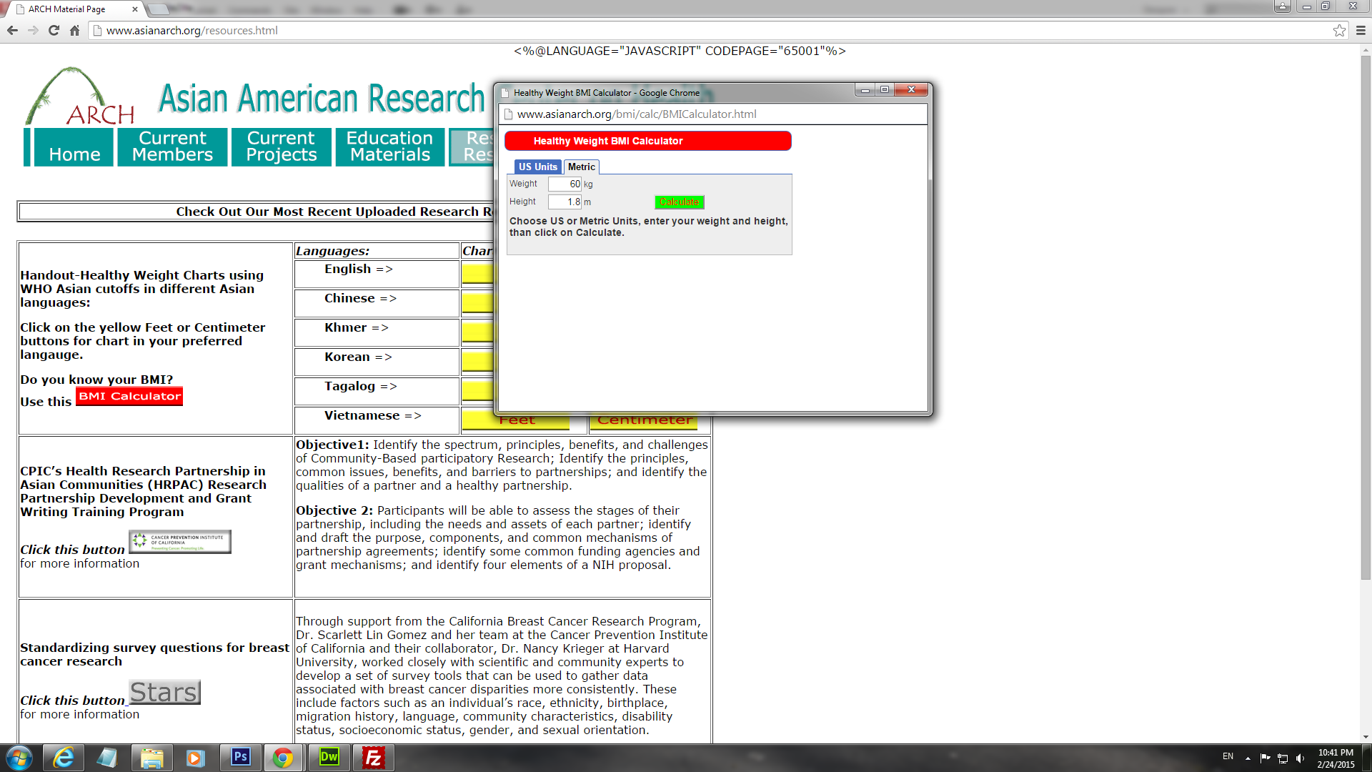

**Changes request:**

1. Move “Choose US or Metric Units, enter your weight and height, then click on Calculate.” Below the read bar and above the US Units / Metric tab. Spelling “than” => “then”.
2. Move Height box up and weight box down. Height should be entered first before weight.
3. Change the text “Height” to “Your height” and “Weight” to “Your weight”.

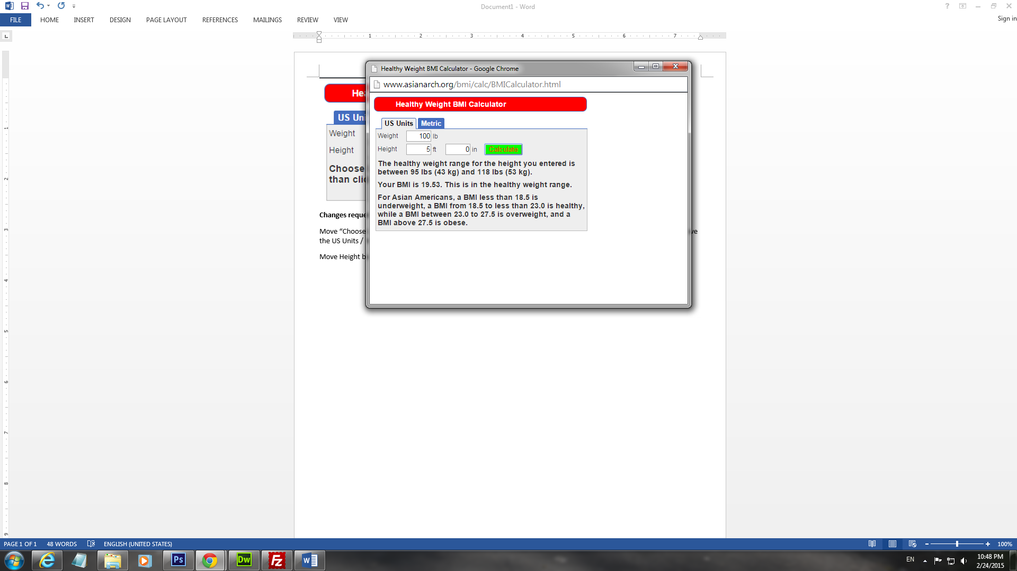

Changes request:

1. Repeat steps 1 and 2 above.
2. Move “Your BMI is 19.53. This is in the healthy weight range up.
3. “The healthy weight range for the height you entered is between 95 lbs (43 Kg) and 118 lbs (53 kg).” should be below the line in step 4.
4. The last paragraph “For Asian American, a BMI less than…” should be in a box or something to separate it from the text in step 4 and 5.

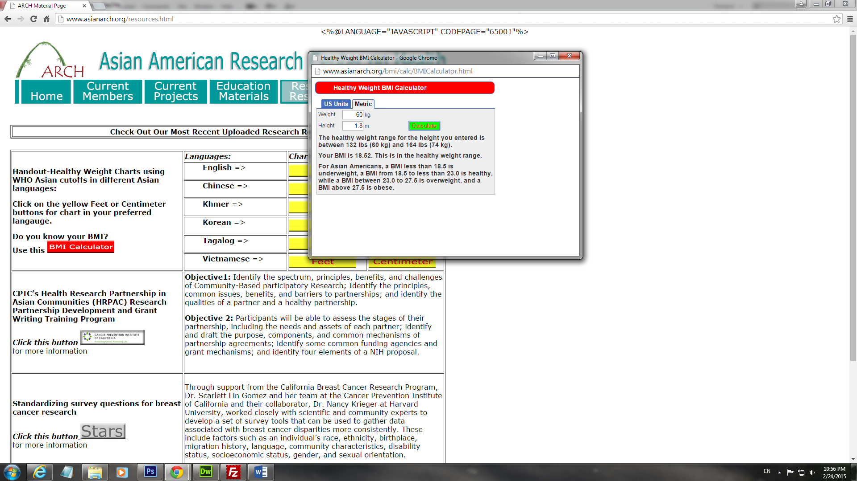

Changes request:

1. Similar to steps 4 to 7.
2. Note that it should be “The healthy weight range for the height you entered is between 60 kg (132 lbs) and 74 kg (164 lbs).